1. 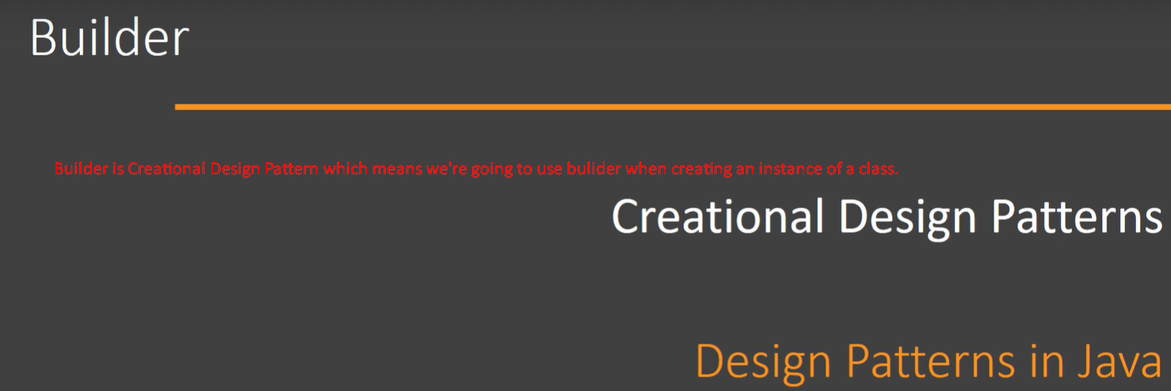

Let’s look at some of the problems solved by this design pattern.

1. Immutable Class:
   1. When creating object for immutable class, we need to pass all the arguments in a constructor.
   2. 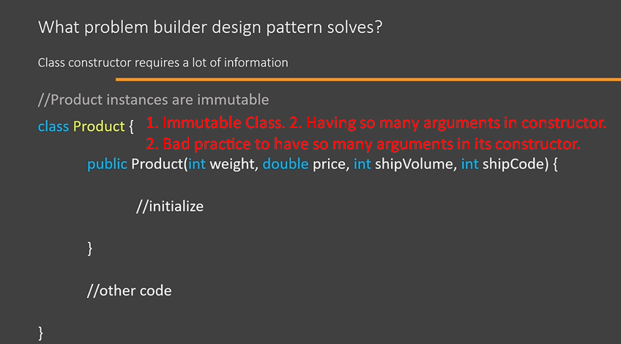
   3. As anyone calling such constructor or method with so long list of arguments needs to know what is the meaning of each parameter.
   4. The problem is compounded if the arguments are of similar data types as then it will become more difficult to understand the purpose of each argument.  
      For example: in the above constructor, there are three arguments of numeric type.
   5. 
   6. Usually, we distribute our code in compiled format in a jar file to other developers.  
      The only way they can find out about these parameters is to refer to your documentation.
   7. Now, Builder design pattern can really help us in such situations.
   8. It can help us in two ways.
      1. It can make it easy for us to use such constructor so that we can create objects of this class.
      2. It will help us avoid such long argument constructor in the first place and still we can create objects of this class.  
         NOTE: We will see all this in next few lectures.
2. Let’s see at the another problem:
   1. Scenario: Where one class constructor takes an object of another class as shown in the following slide.
   2. So, you can see to create User object we needs parts such as User and List<Role> roles as arguments in constructor.
   3. This is a good indication to use Builder Design Pattern.  
      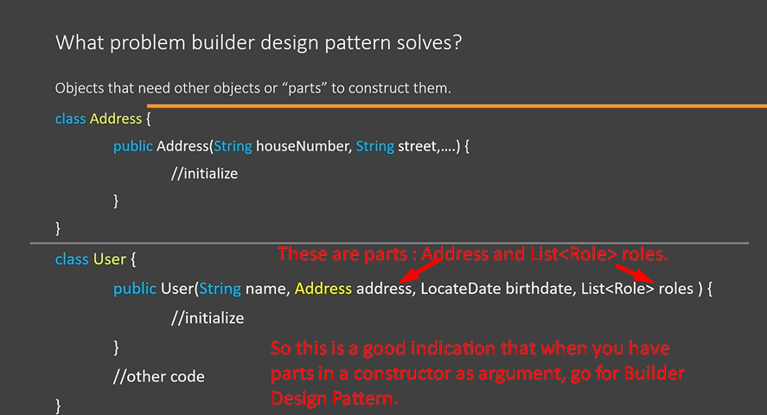  
      So, in the above constructor, we can see that the constructor takes only 3 arguments which those arguments are very complicated. So we need to go for builder design pattern.

What is Builder?

1. 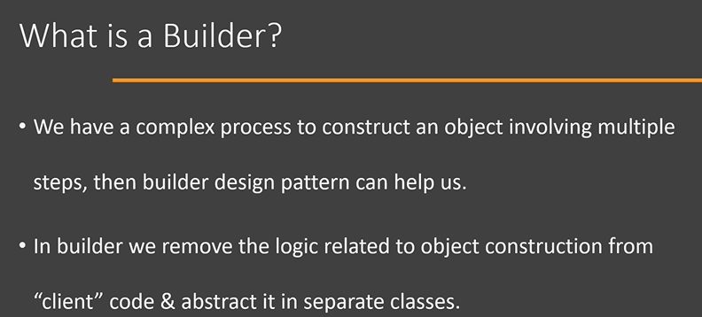The complexity can be
   1. Because of long list of arguments.
   2. Because of the steps needed to create object a class.   
      Such as a constructor taking 2 or 3 arguments but those arguments are very complicated.
2. In nutshell, builder design pattern is used when creating a class object is very complex.

Let’s look at the UML Diagram

1. In this diagram, you can see we have 4 different roles and we will look at them in detail.
2. 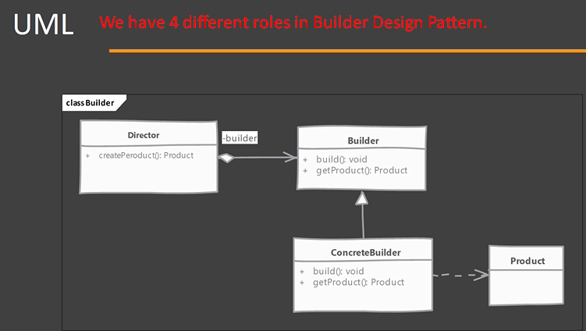
3. 